Final Report Restaurante confusion

An Online Angular-Tutorial and introduction in Front end angular development

# 1. Introduction

The project has the following features. It is a simple representation of an restaurant website with:

* Overview or the website
* The available menu
* An about page
* Information about the leaders

You can view an overview and a brief description of every available menu as well as feedback given by customers. You can give a feedback by yourself.

You can see the history of the restaurant as well as the leaders and the contact information. You can give the restaurant some feedback, but it will not be preserved.

# 2. Design and Implementation

The first step was to design the view and navigation of the several pages with static dummy data.

After the design was standing the next step was to simulate the loading over network and in the next step to implement the server side to get real data.

The last step was to implement a few animations to the website to give it a modern and fresh look.

Used packages were (only a few of them):

@angular: animation, flex-layout, http, material (for dialogs), hammerjs, rxjs, …

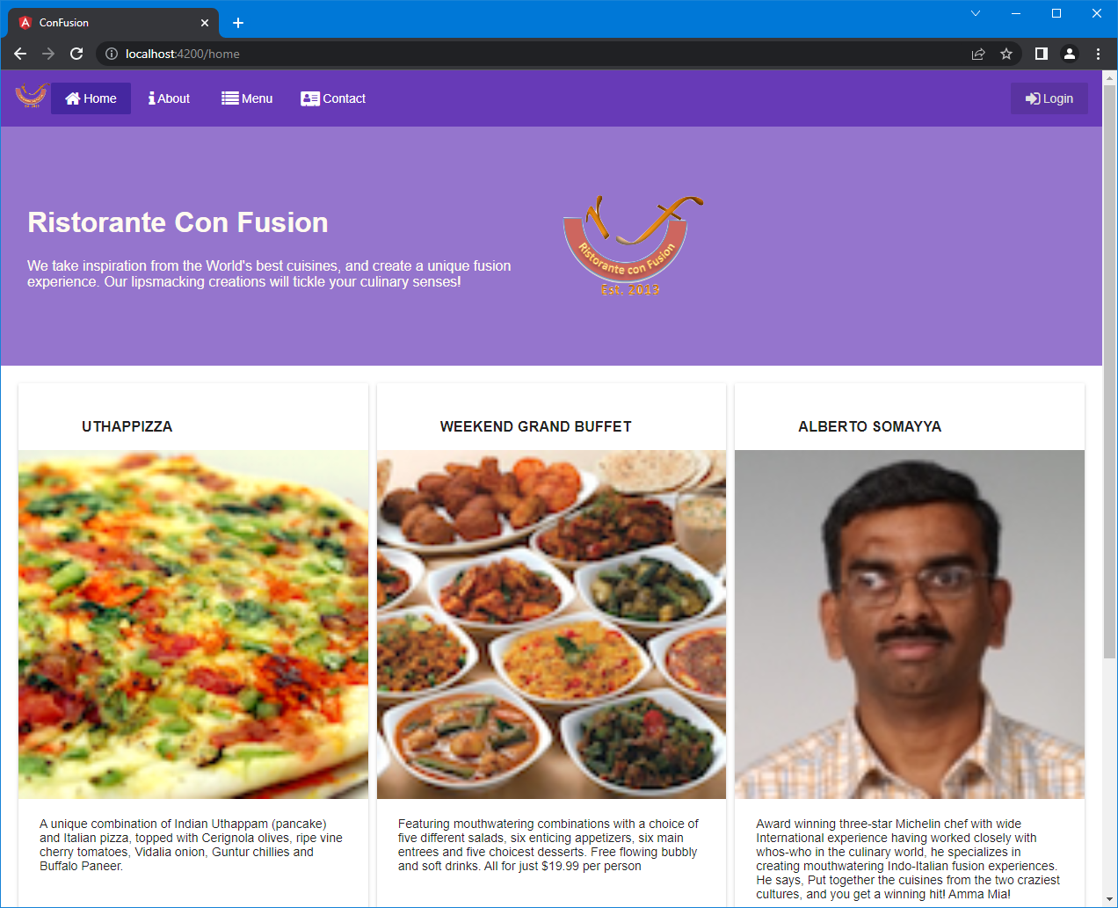

The home page which loads when you visit the site.

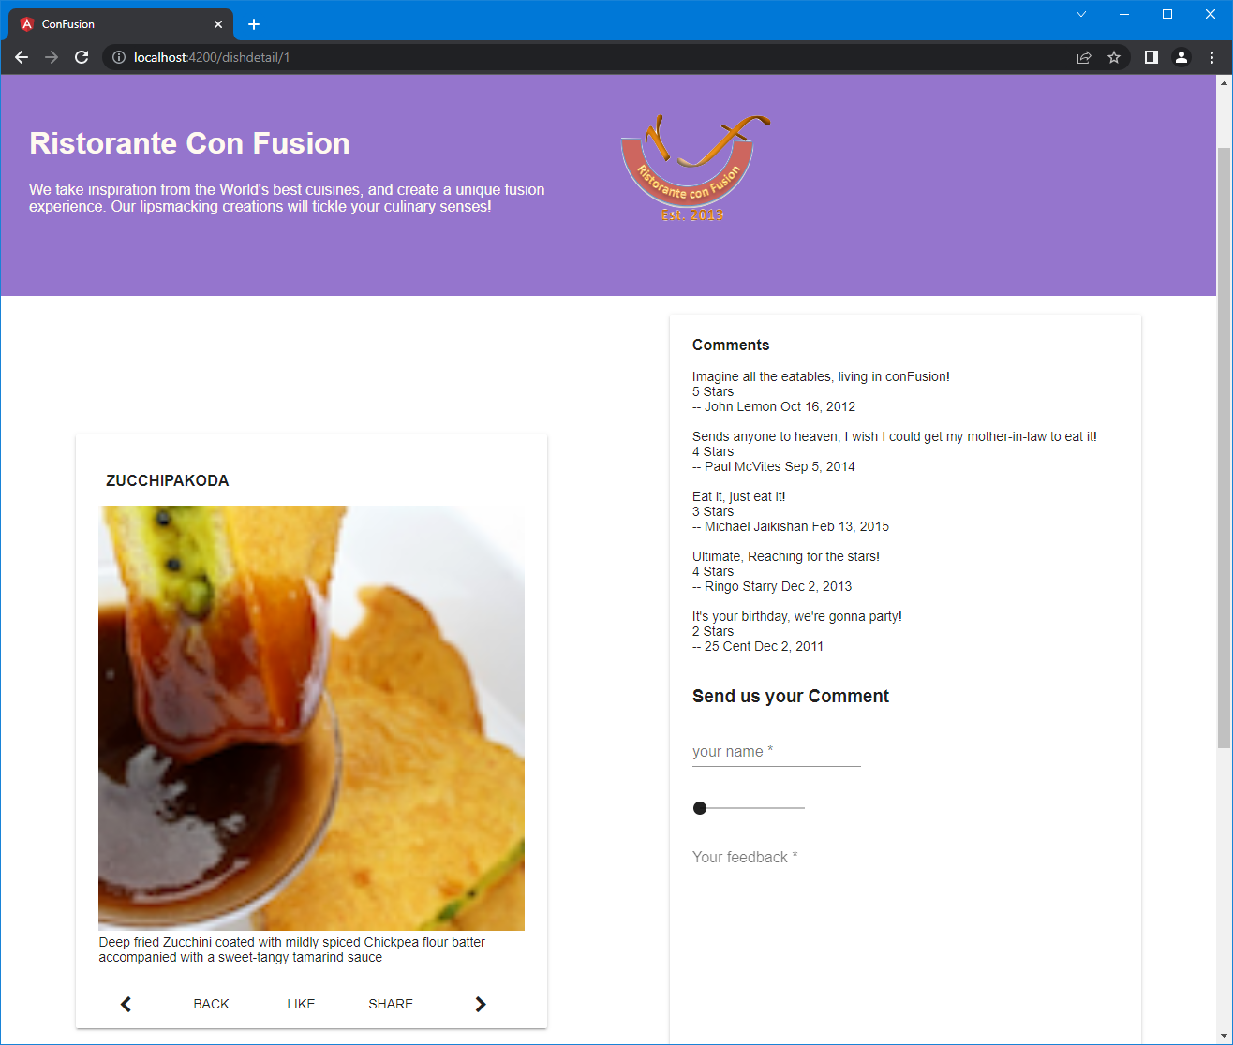

A brief description of the menu besides the comments given to this menu

# 3. Conclusions

The detail page of the menu lacks the feature to delete a given comment (made by yourself) and also a working login page.

The feedback given on the aboutus site is non persistent. E.g. it is neither sent nor persisted on the server side.

The animations are carefully chosen to not overload the visual impact at the viewers side. Only transitions are used.

I would have used the promise statement for several messages when you get one answer after a request.

The project is nice and clean and not overloaded with too much features.

# 4. References

* [dbrunner-artiso/Restaurante-conFusion (github.com)](https://github.com/dbrunner-artiso/Restaurante-conFusion)
* [Front-End JavaScript Frameworks: Angular - Front-End JavaScript Frameworks Overview: Angular | Coursera](https://www.coursera.org/learn/angular/home/week/1)
* [Getting Started | webpack](https://webpack.js.org/guides/getting-started/)